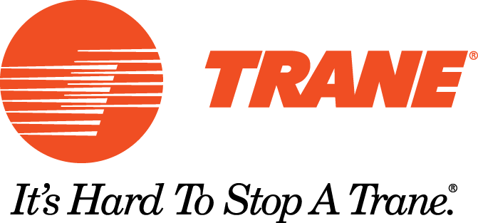
“People who know better…

Buy Trane

Third Party Endorsements

2013 Consumer Reports Most Reliable Gas Furnace
In a survey of 32,251 subscribers Trane furnaces bought between 2007 and 2012 were again rated as one of the most reliable brands.

2012 Consumer Reports Central Air Conditioning Reliability
In a survey of more than 40,000 readers Trane was named the most reliable brand of air conditioner and heat pump installed between 2005 and 2011.

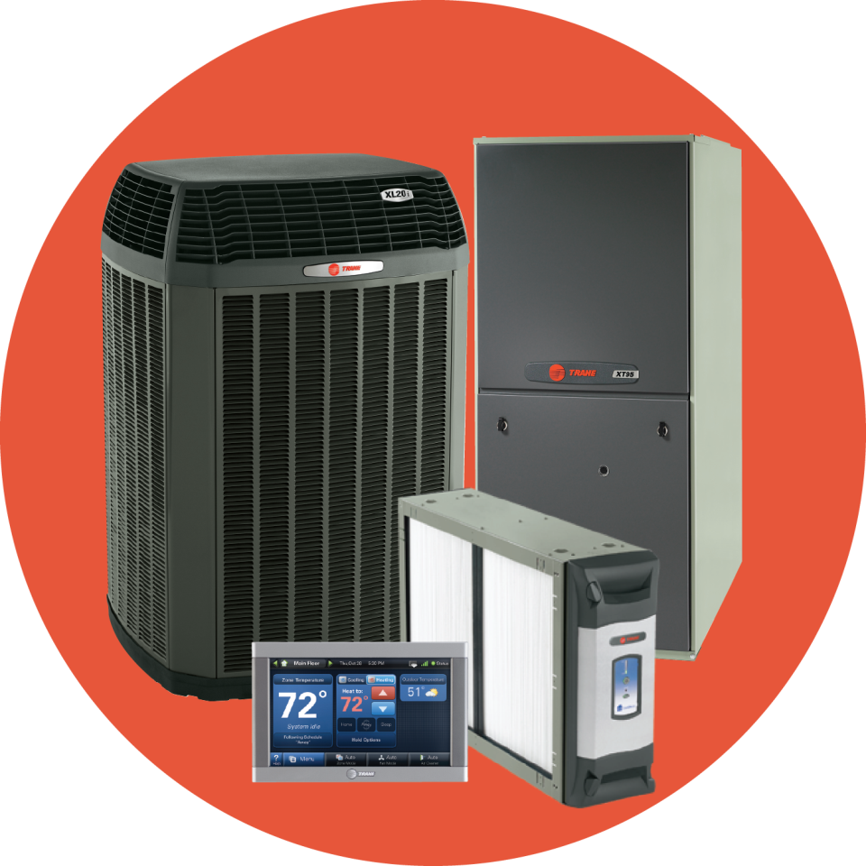
2009 Consumer Reports Most Reliable Brands
In a survey of 32,550 readers that had purchased a new system between 2002 and 2008, Trane was again rated as one of the most reliable brands.

2007 Consumer Reports Pro-Installed Air Cleaners
Trane CleanEffects whole house air cleaner was the top rated electrostatic precipitators with an overall score of 89.

2006 ACHR News Dealer Design Awards
Trane was recognized for excellence in product design by an independent panel of 45 contractors acting as judges on the contest that had 112 entries from 75 manufactures.

2005 Consumer Reports “Furnace Picks and Pans”
Reader’s Report: Their survey on central gas furnaces installed between 1997 and 2004 of over 36,000 respondents showed Trane as the brand requiring the least repairs.

2003 Consumers Digest “Best Buy”
Freedom 80 gas furnaces have been designated as a “Best Buy” in the furnace category. A “Best Buy” is a product identified as a great value in the marketplace.

2002 Consumer Reports “Which Furnace Holds Up Best”
Reader’s Report: Their 2001 annual questionnaire regarding furnaces installed between 1995 and 2001, based on subscriber responses, rated Trane furnaces, “More reliable then average”

2002 Bob Villa’s Home Again
Bob chooses Trane as the brand he wanted in a Medford, Massachusetts renovation of a Victorian era home.

2001 Consumer reports “Most Trouble Free”
Results of a reader survey questionnaire rated Trane air conditioning the “Most Trouble Free” of the 14 leading brands.

2001 ACHR News “Top Brands”
Almost 200 dealer/Contractors were surveyed to rate the product quality of 17 different brands – Trane was rated a “Top Brand”.

1998 Consumers Digest “Best Buy”
Allegiance 14 & 16 SEER air conditioners rated a “Best Buy” in central air conditioning systems.
A “Best Buy” is a product identified as a great value in the marketplace.

1992 HVAC Magazine “Design Award”
The Freedom 80 Two Stage gas furnace was judged by a panel of contractors to be one of the most innovative products for ease of installation, maintenance and repair.

